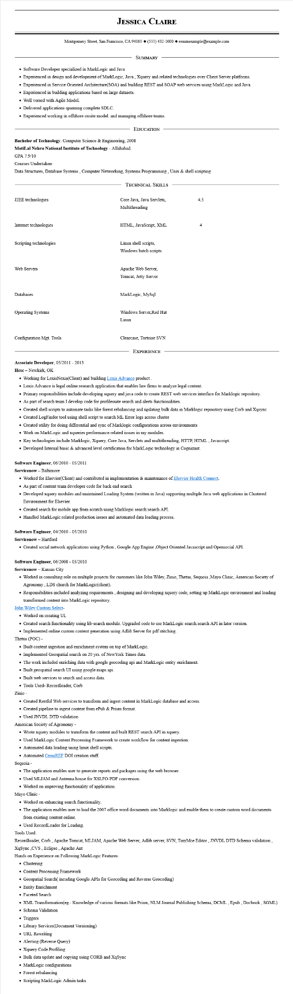
JESSICA CLAIRE
Montgomery Street, San Francisco, CA 94105 ♦ (555) 432-1000 resumesample@example.com
SUMMARY
• Software Developer specialized in MarkLogic and Java
• Experienced in design and development of MarkLogic, Java, Xquery and related technologies over Client Server platforms.
• Experienced in Service Oriented Architecture(SOA) and building REST and SOAP web services using MarkLogic and Java. • Experienced in building applications based on large datasets.
• Well versed with Agile Model.
• Delivered applications spanning complete SDLC.
• Experienced working in offshore onsite model. and managing offshore teams.
EDUCATION
Bachelor of Technology: Computer Science & Engineering, 2008
Motilal Nehru National Institute of Technology - Allahabad GPA 7.9/10
Courses Undertaken-
Data Structures, Database Systems, Computer Networking, Systems Programming, Unix & shell scripting
J2EE technologies
TECHNICAL SKILLS
Core Java, Java Servlets, Multithreading
4.5
Internet technologies
HTML, JavaScript, XML
4
Scripting technologies
Web Servers
Linux shell scripts, Windows batch scripts
Apache Web Server,
Tomcat, Jetty Server
Databases
Operating Systems
Configuration Mgt. Tools
MarkLogic, MySql
Windows Server,Red Hat
Linux
Clearcase, Tortoise SVN
EXPERIENCE
Associate Developer, 05/2011 - 2013
Hcsc - Newkirk, OK
• Working for LexisNexis(Client) and building Lexis Advance product
• Lexis Advance is legal online research application that enables law firms to analyze legal content.
• Primary responsibilities include developing xquery and java code to create REST web services interface for Marklogic repository.
• As part of search team I develop code for profilesuite search and alerts functionalities.
• Created shell scripts to automate tasks like forest rebalancing and updating bulk data in Marklogic repository using Corb and Xqsync
• Created LogFinder tool using shell script to search ML Error logs across cluster
• Created utility for doing differential and sync of Marklogic configurations across environments
• Work on MarkLogic and xqueries performance related issues in my modules.
• Key technologies include Marklogic, Xquery, Core Java, Servlets and multithreading, HTTP, HTML, Javascript.
• Developed Internal basic & advanced level certification for MarkLogic technology in Cognizant.
Software Engineer, 06/2010- 05/2011
Servicenow - Baltimore
• Worked for Elsevier(Client) and contributed in implementation & maintenance of Elsevier Health Connect.
• As part of content team developer code for back end search
• Developed xquery modules and maintained Loading System (written in Java) supporting multiple Java web applications in Clustered Environment for Elsevier.
• Created search for mobile app from scratch using Marklogic search:search API.
• Handled MarkLogic related production issues and automated data loading process.
Software Engineer, 04/2010- 05/2010
Servicenow
Hartford
• Created social network applications using Python, Google App Engine,Object Oriented Javascript and Opensocial API.
Software Engineer, 06/2008 03/2010
Servicenow - Kansas City
• Worked in consulting role on multiple projects for customers like John Wiley, Zinio, Thetus, Sequoia Mayo Clinic, American Society of Agronomy, LDS church for MarkLogic(client).
• Responsibilities included analyzing requirements, designing and developing xquery code, setting up MarkLogic environment and loading transformed content into MarkLogic repository.
John Wiley Custom Select-
• Worked on creating UI.
• Created search functionality using lib-search module. Upgraded code to use MarkLogic search:search API in later version.
• Implemented online custom content generation using Adlib Server for pdf stitching.
Thetus (POC) -
• Built content ingestion and enrichment system on top of MarkLogic.
• Implemented Geospatial search on 20 yrs. of New York Times data.
• The work included enriching data with google geocoding api and MarkLogic entity enrichment.
• Built geospatial search UI using google maps api.
• Built web services to search and access data.
• Tools Used- Recordloader, Corb
Zinio -
• Created Restful Web services to transform and ingest content in MarkLogic database and access.
• Created pipeline to ingest content from ePub & Prism format.
• Used JNVDL DTD validation
American Society of Agronomy -
• Wrote xquery modules to transform the content and built REST search API in xquery.
• Used MarkLogic Content Processing Framework to create workflow for content ingestion.
• Automated data loading using linux shell scripts.
• Automated CrossREF DOI creation stuff.
Sequoia -
• The application enables user to generate reports and packages using the web browser.
• Used MLJAM and Antenna house for XSLFO-PDF conversion.
• Worked on improving functionality of application.
Mayo Clinic
• Worked on enhancing search functionality.
• The application enables user to load the 2007 office word documents into Marklogic and enable them to create custom word documents
from existing content online.
• Used RecordLoader for Loading.
Tools Used:
Recordloader, Corb, Apache Tomcat, MLJAM, Apache Web Server, Adlib server, SVN, TinyMce Editor, JNVDL DTD Schema validation, XqSync,CVS, Eclipse, Apache Ant
Hands on Experience on Following MarkLogic Features-
• Clustering
• Content Processing Framework
• Geospatial Search( incuding Google APIs for Geocoding and Reverse Geocoding)
• Entity Enrichment
Faceted Search
• XML Transformation(eg.- Knowledge of various formats like Prism, NLM Journal Publishing Schema, DCML, Epub, Docbook, SGML)
• Schema Validation
• Triggers
• Library Services (Document Versioning)
• URL Rewriting
• Alerting (Reverse Query)
• Xquery Code Profiling
• Bulk data update and copying using CORB and XqSync
• MarkLogic configurations
• Forest rebalancing
• Scripting MarkLogic Admin tasks

